Assignment -7
Task – 1
Description: AI-generated HTML Page
Task: Ask AI to generate a simple HTML homepage for a "Student Info Portal" with a header, navigation menu, and footer.
Prompt: Generate a simple HTML5 homepage for a 'Student Info Portal' with header, navigation menu, main section, and footer.

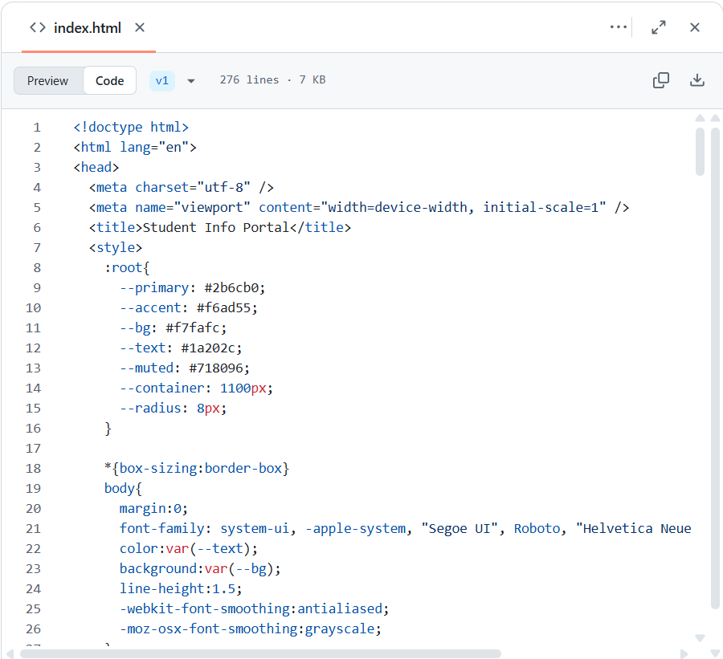
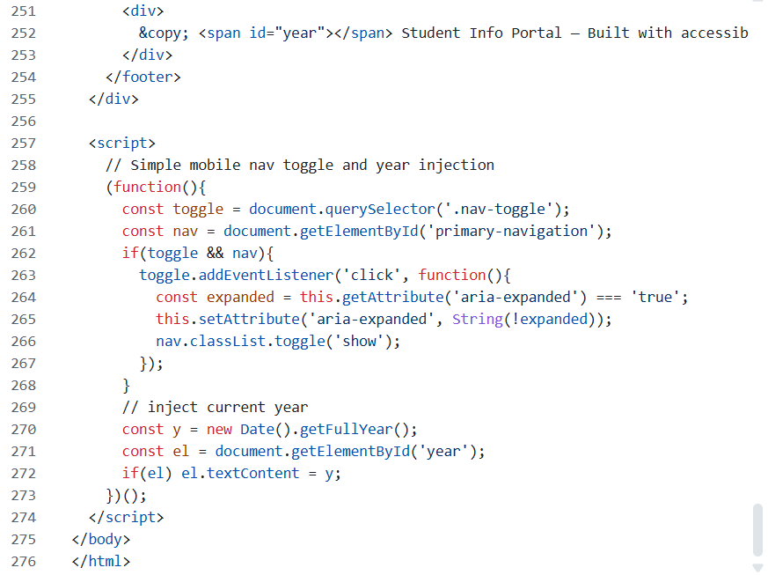

Expected Output:
● HTML code with <header>, <nav>, <footer>.
● Clean indentation, proper tags, and comments.
Practical Output:

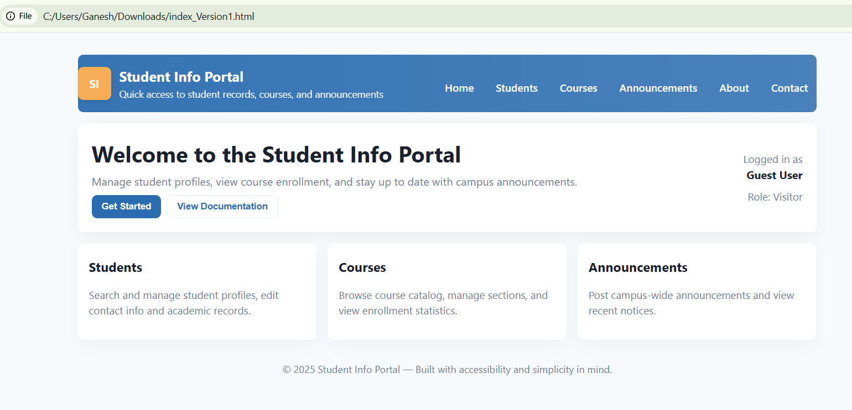
Task -2
Description: CSS Styling
Task: Use AI to add CSS styling to Task #1 homepage for:
● Responsive navigation bar.
● Centered content section.
● Footer with light gray background
Prompt: Add CSS styling to the Student Info Portal HTML page: create a responsive navigation bar, center the main content section, and style the footer with a light-gray background. Use clean, readable CSS with proper comments.

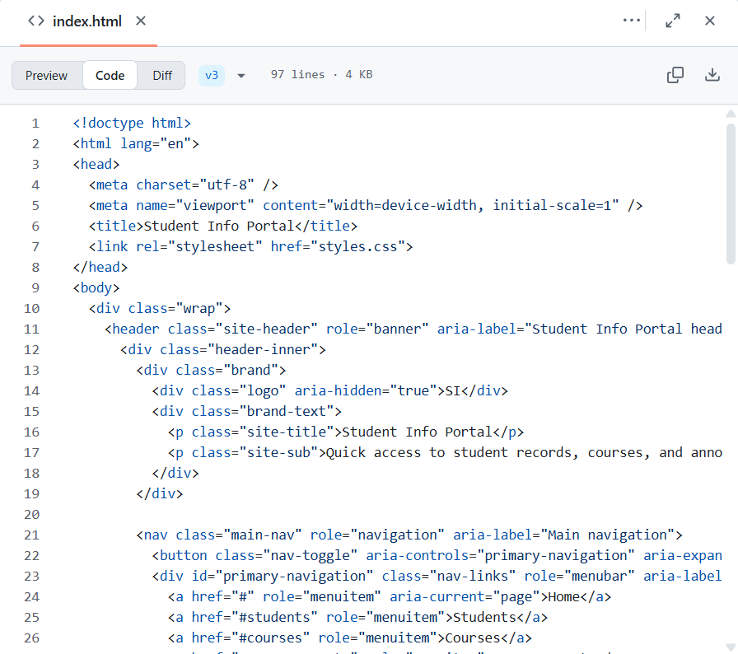
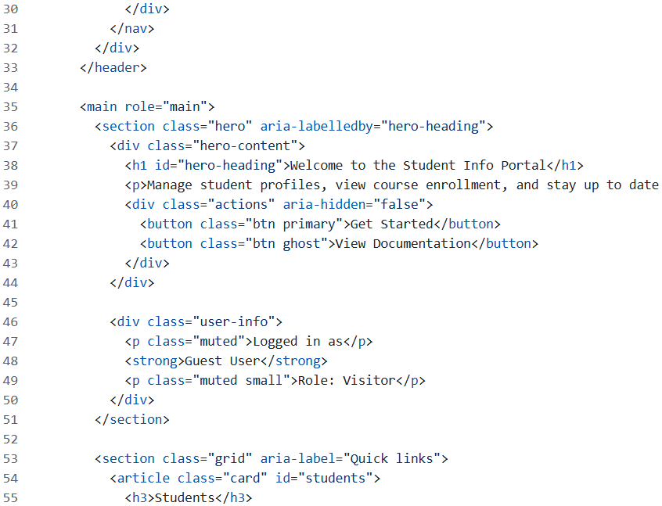
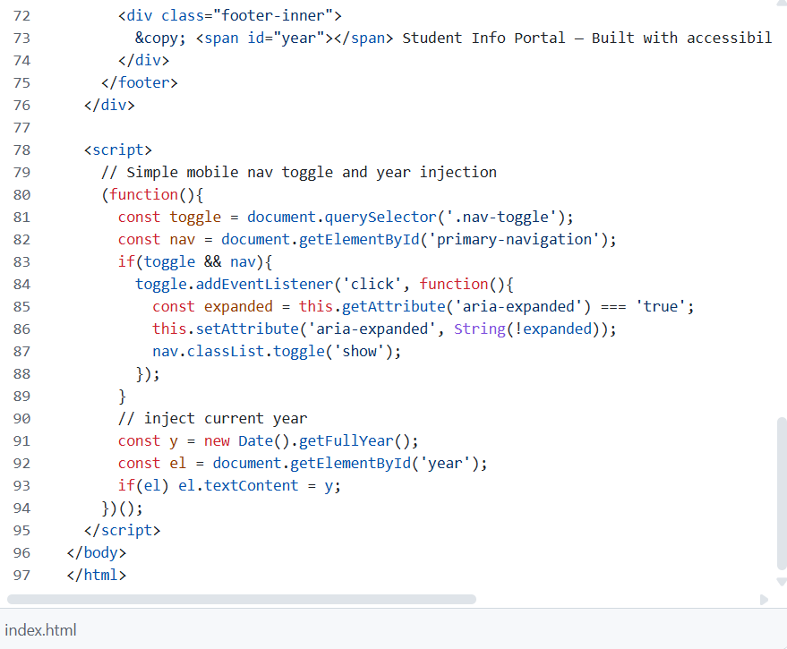
Expected Output:
● HTML + CSS combined.
● AI explains how CSS classes apply.
Expected Output: AI refactors with with open() and try-except.
Practical Output:

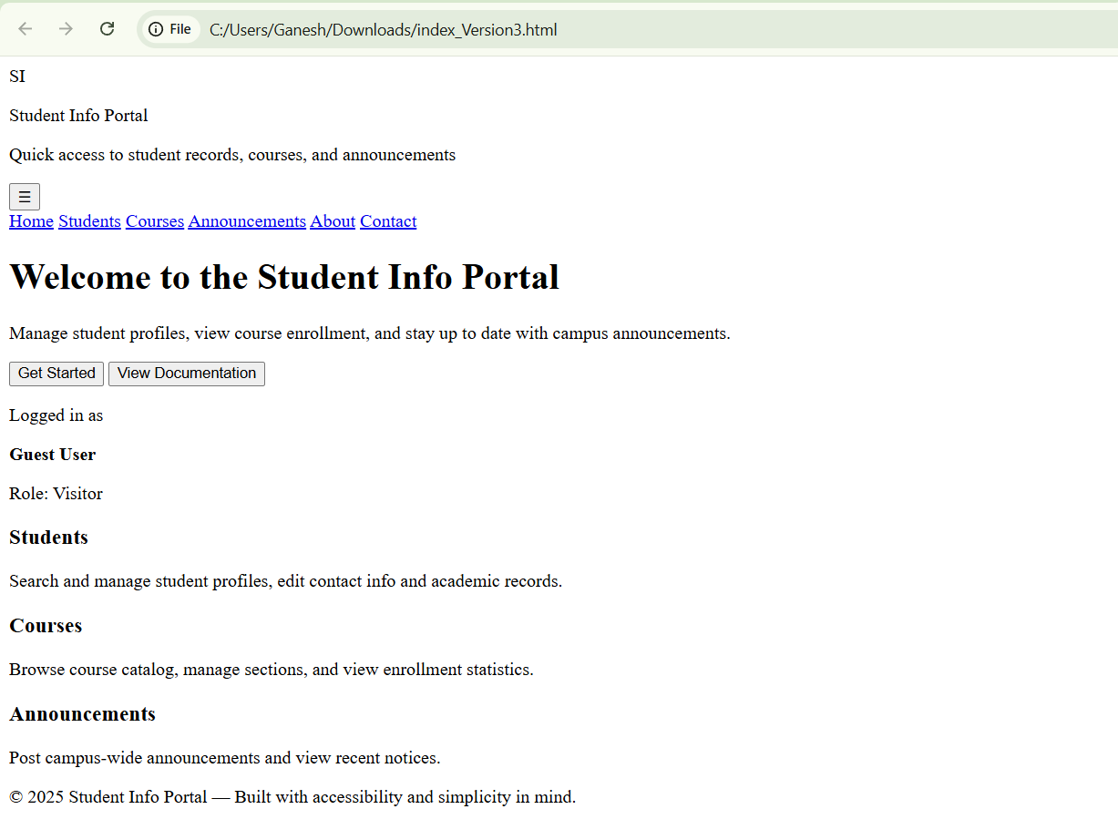

Task – 3
Description: JavaScript Interactivity
Task: Prompt AI to generate a JS script that validates a simple login
form (non-empty username/password).
Prompt: Generate JavaScript code that validates a simple login form by checking that username and password are not empty. Show clear error messages on submit if any field is blank, using clean and well-commented JS.
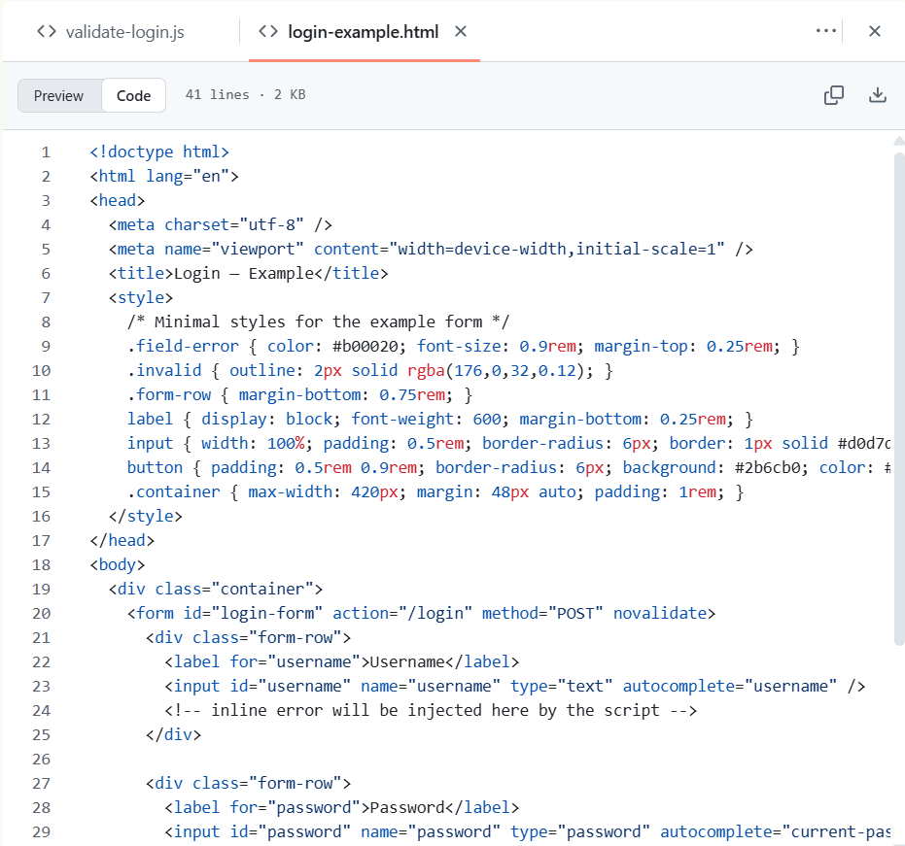
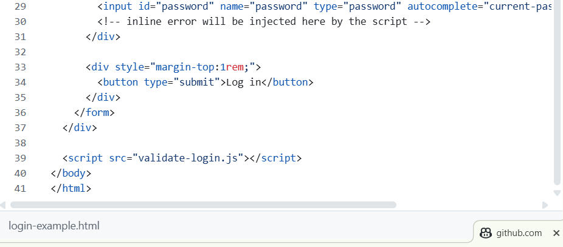

Expected Output:
Working on submit JS validation.
Clear error messages if inputs are empty.
Practical Output:

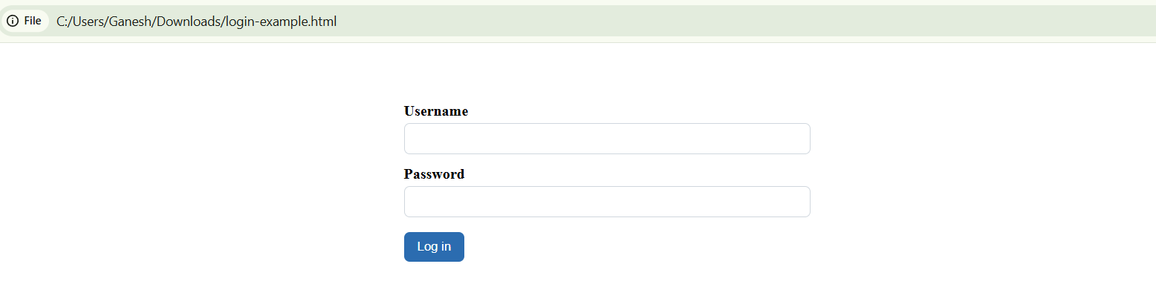

Task – 4
Description: Python Backend Integration
Task: Ask AI to generate a Flask app that serves the HTML form (Task
#3) and prints the username on successful login.
Prompt: Generate a Python Flask app that serves the login form and processes the submitted data. On successful login (non-empty fields), display the entered username; otherwise show an error message.
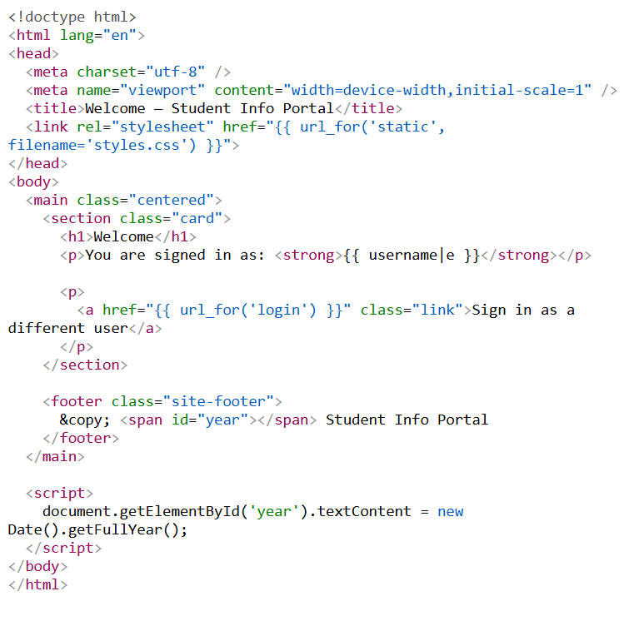

Practical Output:
